# VFX End of Show Data Delivery Specification

*V02.4 April 27th, 2023*

This document outlines the standards and structures in which Amazon Studios expects all our Visual Effects vendors to follow for the End of Show VFX data delivery

## Summary

* Please review the full document, but in summary, for most projects all we need archived are the CG assets, and any shot-related data necessary to re-use the assets.
* It is not required to upload the shots themselves in this delivery; these will be part of the Post Deliverables and dealt with by another team. If there was involvement with virtual production, please see details below for what’s required.
* If it’s unclear what is required to upload, please ask the relevant AS VFX POC. If there is no POC, email [vfx-coord@amazon.com](mailto:vfx-coord@amazon.com).
* Once the material is ready for upload, follow the instructions at the bottom of this document (*2. Upload Procedure and Delivery Manifest*) for how to request access to the upload folder and which documents to fill out. Please ensure the VFX POC / vfx-coord alias is cc’d on any correspondence.
* Be sure to use the Amazon assigned 4 digit Show Code when filling out the form for upload requests as some productions use a different show code than what Amazon has assigned. Please confirm with your VFX Team or AS VFX POC if you are not sure what to use.

## Introduction

We ingest four types of end of show delivery:

1. Assets, which Amazon Studios may wish to re-use in subsequent shows
2. Shot data, primarily for archive
3. Pre-production data, primarily for archive
4. On-Set Playback Plates, live action footage used for in-camera playback

The rest of this document describes the form we expect those deliveries. Section 1 describes in detail the format and content of the deliveries. Section 2 describes the upload process to Amazon Studios.

## 1. Data Delivery Specification

The root directory in all uploads must be named in the following style.

**YYYYMMDD_SHOWCODE_VENDOR NAME_DATATYPE_UPLOADNUMBER**

(The final UPLOADNUMBER being intended to account for cases where the vendor wishes to deliver several packages on a single day)

So, if the vendor (who happened to called ‘BoutiqueVFX’) were to be delivering for the show whose code was UPLO, on the 1st of April 2022, then their first delivery of that day must have a directory at the root of the package called:  
  
20220401_UPLO_BoutiqueVFX_ASSET_1

20220401_UPLO_BoutiqueVFX_SHOT_1

20220401_UPLO_BoutiqueVFX_PREPRO_1

*If you are unsure of what your show code is please check with your Amazon VFX Executive as it should be the 4 digit (letters and/or numbers) code we use for the project.*

**No files or folders should be uploaded in a zipped format. If there are any concerns on file size, contact the VFX POC to discuss options.**

### 1.1 ASSETS

This asset data is primarily used by Amazon Studios at the commencement of subsequent projects, where possible re-use has been identified and we wish to pass the data used on a previous show onto a new VFX vendor. As such we are collecting data in a form suited for subsequent re-ingestion by another VFX company.

We mandate a strict directory structure so that we are able to automate tracking incoming end-of-show deliveries.

Facilities are free to deliver the required data in any number of individual packages, but each must conform to the directory/naming defined below.

Within that directory we expect the assets to be categories by ‘class’ of the asset, with the required sub-folders for each classification of asset being delivered. We expect the following classifications

* + Characters, under a Characters directory
  + Environments, under an Environments directory
  + Vehicles, under a Vehicles directory
  + Props, within a Props
  + HDR, under a HDR directory
  + Where require facilities can delivery misc raw elements under a Misc directory. Contents might include:
    - raw FX elements
    - PBR materials, Substance materials
  + Concept art used to drive the design and build of the asset. All the material should be in a Concepts directory.

Furthermore, the delivered assets should contain only hero/finished assets, we don’t need work-in-progress versions of the asset.

Each asset should have a unique descriptive name, such as HeroSword

Each asset should live in its own folder (beneath the class, for example /Props/HeroSword/) and should contain all the data required to reproduce the asset outside of the source VFX studio. In particular it should contain the geometry for the asset, textures and at least material descriptions (see below) as well as reference imagery to indicate how the asset appeared in the VFX vendors pipeline.

#### Reference Material

As the purpose of this delivery is to allow us to pass the asset onto subsequent VFX vendors, we require reference material showing a fully rendered version of the asset, and documentation describing how the rest of the material supplied in the delivery might be used to recreate the reference imagery.

As a result we expect the following files to be present in all asset directories:

* A quicktime showing a turntable of the asset rendered in the source VFX vendors pipeline
* A single image (JPEG, EXR or PNG) showing a representative render of the asset.
* Shading documentation. As VFX houses will have their own process of shading we expect a written explanation of how the supplied textures would be used in another facilities rendering pipeline to reproduce (as much as possible) the supplied turntable. This document should be provided as either plain text or a PDF.  
  Note that while this shading approach will often be replicated across many assets from a VFX vendor we expect the document to be repeated in each appropriate asset folder.   
  We expect this documentation to be written in a way where a similarly capable VFX vendor would be able to recreate the asset within their own rendering toolchain.

#### Geometry

Acceptable geometry file formats in decreasing order of preference for geometry are:  
  
    USD (either binary or ASCII), Alembic, FBX, DCC specific (ma, hip, max)  
  
Note that for those assets supplied as USD files, and which are composed of multiple smaller files, such as environments, all referenced files must be contained beneath the appropriate sub-folder.  
  
The geometry should contain sufficient ‘extra’ data necessary for driving the shading model. For example, all the used UV sets should be present, as well as any extra primvar data needed for shading.

#### Textures

Textures (including any utility textures) should be supplied as EXR’s (as used within the turntable render, so typically mip-mapped). Facilities are welcome to create sub-directories to match how they themselves store the data.

#### Extra Data

For certain asset types it may be necessary to include additional geometry & documentation as required to guide a secondary VFX vendor to ingest and reproduce the asset. This should be supplied in a subdirectory called Extra.

For example, if the character asset includes CG hair, we would expect secondary geometry files to contain guide hairs, and the package to also contain a document (again plain text or PDF) describing how the files contributed to the final rendered asset.

If possible, a glTF model would be included as part of the ‘extra’ data.

#### Concepts

VFX vendors should include concept art relating to the build of the supplied asset within here.

### Example Delivery

The directory structure, and contained files, for a single asset delivery (with two very simple assets) would appear as:

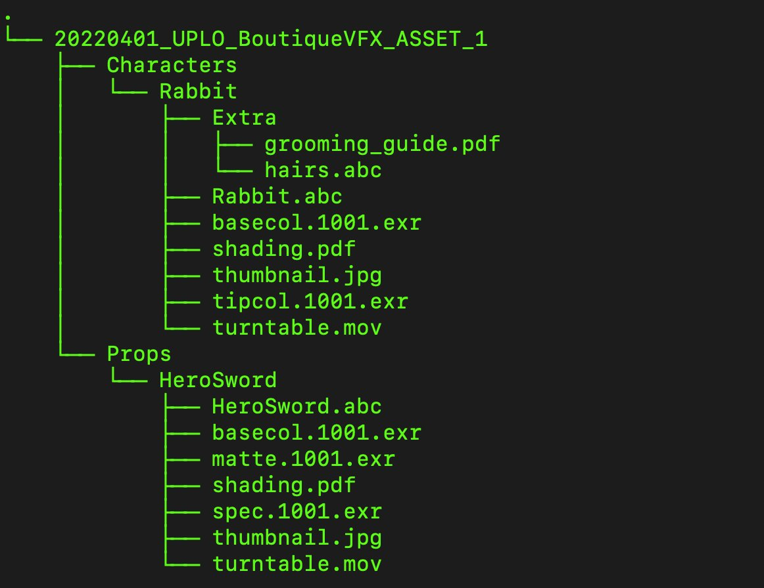

### 1.2 SHOT DATA

Data related to all the finished shot work delivered as part of the production which will be uploaded to Amazon Studios. The shot data will be primarily for archive and not for future reuse. Therefore, the directory structure is less crucial and can follow the vendor’s established coherent standards.

Shot data may include: Nuke scripts, render passes, lighting scenes, solved/tracked cameras, final EXRs and any other shot specific work.

### 1.3 PRE-PRODUCTION DATA

Data related to any pre-production work as part of the production which will be uploaded to Amazon Studios. The pre-production data will be primarily for archive and not for future reuse. Therefore the directory structure is less crucial and can follow the vendor’s established coherent standards.

Pre-production data is defined as any data that was not directly used in the creation of the VFX shots. This may include: any Visualization Animations (pre, post, tech, stunt, etc), Reference photography or video, mood boards, lighting keys, vfx concepts, diagrams/blueprints (construction, art, setdec), files for 3D printing.

### 1.4 PLAYBACK PLATES

Live action plates (or CGI generated plates) used for playback on LED screens (or similar on-set playback device) will be uploaded to Amazon Studios.

The Digital Plate Archive File Naming shall apply to all un-stitched single camera (or arch) and stitched plates. The naming scheme will differ slightly depending on whether the archive is from **un-stitched single cameras, archs,** or **a final stitched** sequence (or movie file).

All **PLATES** sequence files and movie files shall include the following base name structure:

· **FullShowName** (or abbreviated name)

· **Camera type** (alexa, alexa65, red, varicam, F55, ENG, bmpc, etc.)

· **Resolution** (2048x1024, 4096x2160, 8192x4320, etc.)

· **Color Space:** (AWG, RedWG, P3D65, Rec709, Rec2020, etc)

· **Transfer Function:**  (LogC, PQ, RedLog HLG, sRGB, G24, etc).

· **Lab Roll or Camera Roll**

· **Scene #**

· **Take #**

· **Unstiched/Arch # or Stiched:** This will be the camera or arch number, for example “Cam1,” “Cam2,” “Arch1,” etc. If the sequence is one uniform stitch, then use “Stiched” in this place.

· **Frame Rate** (2398fps, 24fps, 25fps, 2997, 30fps, 60fps, 120fps, etc.)

· **Frame number with leading zeros**

· **Appropriate image file format extension** (tif,dpx,mov)

· **Examples**:

*TheBoysS2_ArriMiniLf_*3840x2160_LogC_AWG*_011_Scene031a_Take02_Arch3_24fps.000501.tif*

If the filenames do not meet the requirements as detailed, please provide documentation with the information linking it to the delivered filenames.

Files to be delivered:

* Final media used on-set for playback (exr, NotchLC Quicktime, etc...)
* Final media, **BEFORE** conversion to format needed by on-set playback system
* LUTs used during on-set playback
* Manifest that describes resolution of files, gamut, and transfer function used for playback
* If CGI was composited into live action footage for playback, deliver underlying live action footage without CGI
* Un-stitched plates (if the final product used on-set was stitched)
* Raw camera files of original captured footage

## 2. Upload Procedure and Delivery Manifest

A.) To optimize archival requests, we would like to solicit your help using our[Media Asset Archive Request](https://support.amazonstudios.com/hc/en-us/requests/new?ticket_form_id=14852999206420) form, located in our [Studios Technology Support Desk Portal](https://support.amazonstudios.com/hc/en-us). When filling out the form please make sure to have “VFX” and the 4 digit Amazon Show Code in the Subject field and Type of Delivery field so that it is routed to the proper Amazon contacts for approval. Be sure to use the **4 digit Amazon Show Code**. If you are not sure what that is please confirm with your VFX team or Amazon VFX Exec team. Sometimes, production uses a different 4 digit show code internally, so please double check what the 4-digit *Amazon* Show Code is if you are not sure.

The goal of this from is to reduce setup time for the vendor and for Amazon Studios. The information provided will help the Technology Services team quickly provide guidance about which media archive tool to use.

When the vendor fills out the form and submits, the ticket will be routed to our Tech Ops & Support Desk. Once the ticket is completed, an e-mail will be sent to the Requestor, MAM, and CSA for visibility. Please add Amazon VFX coord alias to be cc’d **-**[**vfx-coord@amazon.com**](mailto:vfx-coord@amazon.com) - in the Description field so that we can ensure Amazon VFX team has visibility and can follow up. If anyone wants to be cc’d, add that info in the Description field as well.

**After your upload has completed, please be sure to notify the teams on the same email chain that it is done.

B.) Delivery Manifest template (AZS_VFX_Digital_Asset_Manifest_YYYYMMDD.xlsm) must be opened as a Macro Enabled workbook in order to keep the drop down lists for specific columns that we have provided. Please be sure to click “Enable Macros” when opening the file in order to access this information. You can deliver this sheet via email, via the form mentioned in part A and/or included in the parent folder of your archive upload. If you have any questions or issues with this form, please reach out to your VFX Executive/Coordinator.